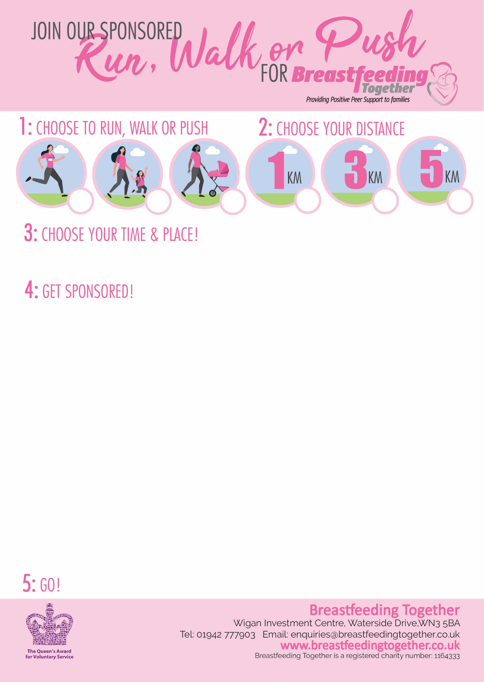­­­­­­­

**Name:**

**Address: (only required for gift aid)**

**Amount:**

**Paid:**

**Gift Aid:**

**My Date:**

**Location:**